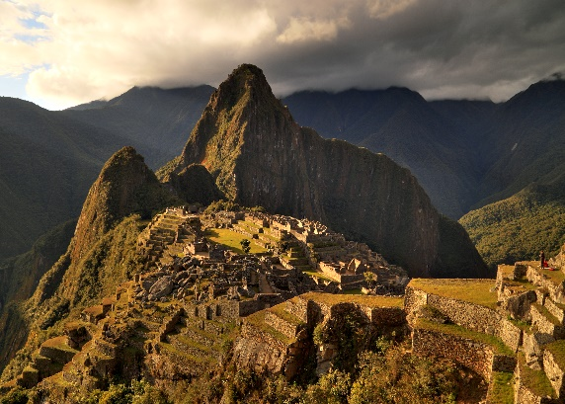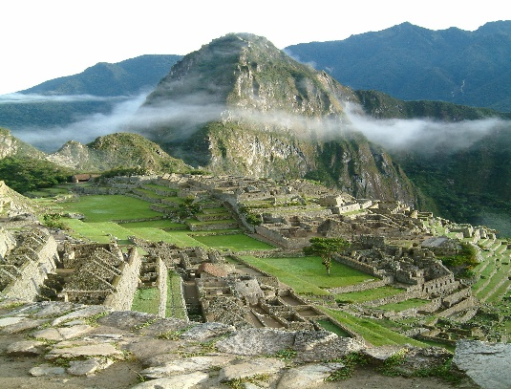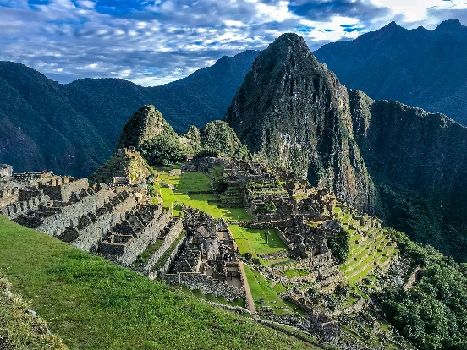

# Machu Picchu

**Machu Picchu**[[a]](https://en.wikipedia.org/wiki/Machu_Picchu#cite_note-9) is a 15th-century [Inca](https://en.wikipedia.org/wiki/Inca_Empire) [citadel](https://en.wikipedia.org/wiki/Citadel) located in the [Eastern Cordillera](https://en.wikipedia.org/wiki/Cordillera_Oriental_(Peru)) of southern [Peru](https://en.wikipedia.org/wiki/Peru) on a mountain ridge at 2,430 meters (7,970 ft).[[9]](https://en.wikipedia.org/wiki/Machu_Picchu#cite_note-unesco-10) Often referred to as the "Lost City of the Incas",[[10]](https://en.wikipedia.org/wiki/Machu_Picchu" \l "cite_note-11) it is the most familiar icon of the [Inca Empire](https://en.wikipedia.org/wiki/Inca_Empire). It is located in the [Machupicchu District](https://en.wikipedia.org/wiki/Machupicchu_District" \o "Machupicchu District) within the [Urubamba Province](https://en.wikipedia.org/wiki/Urubamba_Province)[[11]](https://en.wikipedia.org/wiki/Machu_Picchu#cite_note-12) above the [Sacred Valley](https://en.wikipedia.org/wiki/Sacred_Valley), which is 80 kilometers (50 mi) northwest of the city of [Cusco](https://en.wikipedia.org/wiki/Cusco). The [Urubamba River](https://en.wikipedia.org/wiki/Urubamba_River) flows past it, cutting through the Cordillera and creating a canyon with a subtropical mountain climate.[[12]](https://en.wikipedia.org/wiki/Machu_Picchu#cite_note-13)

The [Inca civilization](https://en.wikipedia.org/wiki/History_of_the_Incas) had no written language and following the first encounter by the Spanish soldier [Baltasar Ocampo](https://en.wikipedia.org/wiki/Baltasar_de_Ocampo_Conejeros" \o "Baltasar de Ocampo Conejeros), no Europeans are recorded to have visited the site from the late 16th century until the 19th century. As far as historical knowledge extends, there are no existing written records detailing the site during its period of active use. The leading theory is that Machu Picchu was a private city for Incan royalty. The names of the buildings, their supposed uses, and their inhabitants, are the product of modern archaeologists based on physical evidence, including tombs at the site. Machu Picchu was built in the classical Inca style, with polished [dry-stone walls](https://en.wikipedia.org/wiki/Dry-stone_wall). Its three primary structures are the *Temple of the Sun*, the *Temple of the Three Windows,* and the *[Intihuatana](https://en.wikipedia.org/wiki/Intihuatana,_Urubamba" \o "Intihuatana, Urubamba)*. From 1929 to 1971, Machu Picchu underwent extensive restoration and conservation work, including structural stabilization and artifact excavation, driven by government initiatives and research expeditions.[[13]](https://en.wikipedia.org/wiki/Machu_Picchu#cite_note-FOOTNOTEBastanteAsteteFern%C3%A1ndezUsca2020a167%E2%80%93170-14) Most recent [archaeologists](https://en.wikipedia.org/wiki/Archaeologists) believe that Machu Picchu was constructed as an estate for the Inca emperor [Pachacuti](https://en.wikipedia.org/wiki/Pachacuti" \o "Pachacuti) (1438–1472). The Inca built the estate around 1450 but abandoned it a century later, at the time of the [Spanish conquest](https://en.wikipedia.org/wiki/Spanish_conquest_of_the_Inca_Empire). According to the new [AMS radiocarbon dating](https://en.wikipedia.org/wiki/AMS_radiocarbon_dating), it was occupied from c. 1420–1532.[[14]](https://en.wikipedia.org/wiki/Machu_Picchu#cite_note-15) Historical research published in 2022 claims that the site was probably called Huayna Picchu by the Inca people themselves, as it exists on the smaller peak of the same name.[[15]](https://en.wikipedia.org/wiki/Machu_Picchu#cite_note-:0-16)[[16]](https://en.wikipedia.org/wiki/Machu_Picchu#cite_note-17)

Machu Picchu was declared a Peruvian Historic Sanctuary in 1982 and a [UNESCO](https://en.wikipedia.org/wiki/UNESCO) [World Heritage Site](https://en.wikipedia.org/wiki/World_Heritage_Site) in 1983.[[9]](https://en.wikipedia.org/wiki/Machu_Picchu#cite_note-unesco-10) In 2007, Machu Picchu was voted one of the [New Seven Wonders of the World](https://en.wikipedia.org/wiki/New7Wonders_of_the_World#Winners) in a worldwide internet poll.[[](https://en.wikipedia.org/wiki/Machu_Picchu#cite_note-18)

## **History**

Machu Picchu was previously believed (by [Richard L. Burger](https://en.wikipedia.org/wiki/Richard_L._Burger), professor of [anthropology](https://en.wikipedia.org/wiki/Anthropology) at [Yale University](https://en.wikipedia.org/wiki/Yale_University)) to have been built in the 1450s.[[1]](https://en.wikipedia.org/wiki/Machu_Picchu#cite_note-FOOTNOTEBurgerSalazar200427-1) However, a 2021 study led by Burger used [radiocarbon dating](https://en.wikipedia.org/wiki/Radiocarbon_dating) (specifically, [AMS](https://en.wikipedia.org/wiki/Accelerator_mass_spectrometry)) to reveal that Machu Picchu may have been occupied from around 1420 to 1530 AD.[[21]](https://en.wikipedia.org/wiki/Machu_Picchu#cite_note-23)[[22]](https://en.wikipedia.org/wiki/Machu_Picchu#cite_note-24) Construction appears to date from two great Inca rulers, [Pachacutec Inca Yupanqui](https://en.wikipedia.org/wiki/Pachacuti" \o "Pachacuti) (1438–1471) and [Túpac Inca Yupanqui](https://en.wikipedia.org/wiki/Topa_Inca_Yupanqui" \o "Topa Inca Yupanqui) (1472–1493).[[23]](https://en.wikipedia.org/wiki/Machu_Picchu#cite_note-FOOTNOTEBastanteFern%C3%A1ndez2020a269%E2%80%93288-25)[[24]](https://en.wikipedia.org/wiki/Machu_Picchu#cite_note-Hiram-26): xxxvi

A consensus among archaeologists is that Pachacutec ordered the construction of the royal estate for his use as a retreat, most likely after a successful military campaign. Although Machu Picchu is considered to be a "royal" estate, it would not have been passed down in the line of [succession](https://en.wikipedia.org/wiki/Order_of_succession). Rather it was used for 80 years before being abandoned, seemingly because of the [Spanish conquests](https://en.wikipedia.org/wiki/Spanish_conquest_of_the_Inca_Empire) in other parts of the [Inca Empire](https://en.wikipedia.org/wiki/Inca_Empire).[[1]](https://en.wikipedia.org/wiki/Machu_Picchu#cite_note-FOOTNOTEBurgerSalazar200427-1) It is possible that most of its inhabitants died from [smallpox](https://en.wikipedia.org/wiki/Smallpox) introduced by travelers before the Spanish [conquistadors](https://en.wikipedia.org/wiki/Conquistador) even arrived in the area.[[25]](https://en.wikipedia.org/wiki/Machu_Picchu#cite_note-27)

During its use as an estate, it is estimated that about 750 people lived there, with most serving as support staff (*[yanaconas](https://en.wikipedia.org/wiki/Yanakuna" \o "Yanakuna), yana)*[[26]](https://en.wikipedia.org/wiki/Machu_Picchu#cite_note-FOOTNOTEBurgerSalazar200424-28)[[27]](https://en.wikipedia.org/wiki/Machu_Picchu#cite_note-:1-29) who lived there permanently. Though the estate belonged to Pachacutec, religious specialists and temporary specialized workers (*mayocs*) lived there as well, most likely for the ruler's well-being and enjoyment. During the harsher season[[*when?*](https://en.wikipedia.org/wiki/Wikipedia:Manual_of_Style/Dates_and_numbers#Chronological_items)], staffing was reduced to a few hundred servants and a few religious specialists focused on maintenance alone.[[28]](https://en.wikipedia.org/wiki/Machu_Picchu#cite_note-FOOTNOTEBurgerSalazar200486-30)

Studies show that, according to their skeletal remains, most people who lived there were immigrants from diverse backgrounds. They lacked the chemical markers and [osteological](https://en.wikipedia.org/wiki/Osteology) markers they would have if they had been living there their entire lives. Instead, research into skeletal remains has found bone damage from various species of water [parasites](https://en.wikipedia.org/wiki/Parasites_of_humans) indigenous to different areas of Peru. There were also varying osteological stressors and varying chemical densities suggesting varying long-term diets characteristic of specific regions that were spaced apart.[[29]](https://en.wikipedia.org/wiki/Machu_Picchu#cite_note-:3-31) These diets are composed of varying levels of [maize](https://en.wikipedia.org/wiki/Maize), [potatoes](https://en.wikipedia.org/wiki/Potato), [grains](https://en.wikipedia.org/wiki/Grain), [legumes](https://en.wikipedia.org/wiki/Legume), and [fish](https://en.wikipedia.org/wiki/Fish), but the last-known short-term diet for these people was overall composed of less fish and more corn. This suggests that several of the immigrants were from more coastal areas and moved to Machu Picchu where corn was a larger portion of food intake.[[27]](https://en.wikipedia.org/wiki/Machu_Picchu#cite_note-:1-29) Most skeletal remains found at the site had lower levels of [arthritis](https://en.wikipedia.org/wiki/Arthritis) and [bone fractures](https://en.wikipedia.org/wiki/Bone_fracture) than those found in most sites of the [Inca Empire](https://en.wikipedia.org/wiki/Inca_Empire). Incan individuals who had arthritis and bone fractures were typically those who performed heavy physical labor (such as the [Mit'a](https://en.wikipedia.org/wiki/Mit%27a" \o "Mit'a)) or served in the [Inca military](https://en.wikipedia.org/wiki/Inca_army).